**JMeter Pre & Post Processors**

**Pre Processor**

Pre Processor executes before the sampler execution. Post Processors are used to execute the response data from the server and to save the specific extracted values for later use.

User parameter: -

The User Parameters Pre-processor specifies user input parameters specific to individual threads. For each thread, the variable value will be used based on the order of that user thread in sequence.

Steps:

* Open JMeter 🡪 Create new thread 🡪 thread group
* Add 🡪 Pre Processor 🡪 User Parameter

* Click Add Variable 🡪 add name and user variable

* Add 🡪 Sampler 🡪 HTTP Request

Create 2 request with name and variable in the format request 1 ${name1} & request 2${name2} with server name as jmeter.apache.org

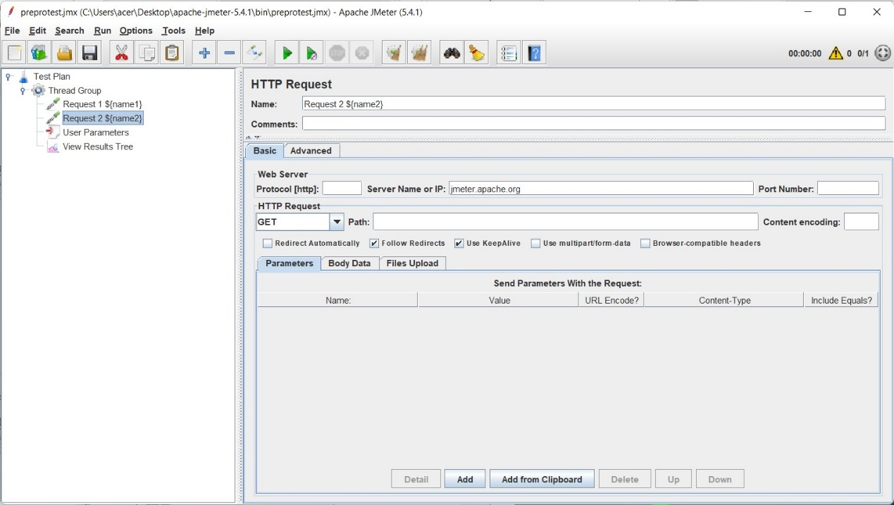

* Run

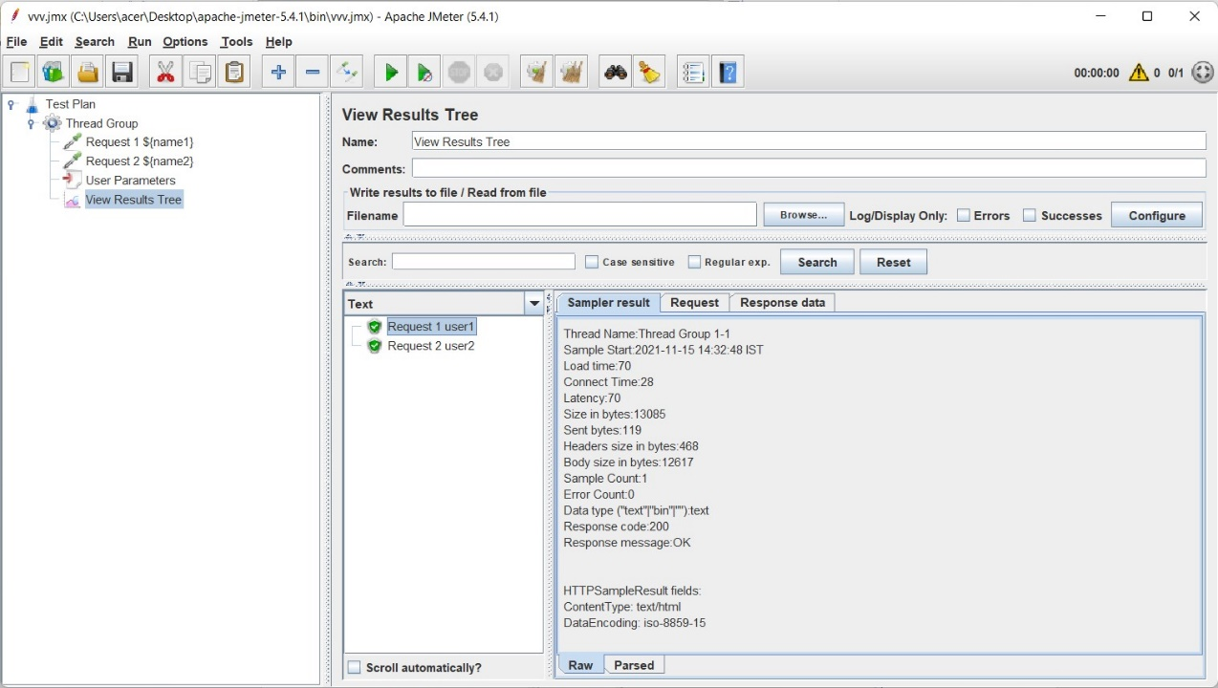

HTML Link Parser

The HTML Link Parser Pre-processor can be used to parse a response, extract all the found links and request them further. This can be useful when the main goal of your script is to simulate web crawling.

Steps:

* Create a Thread Group
* Add HTTP Request
* Add another HTTP Request and add HTML Link Parser inside this request

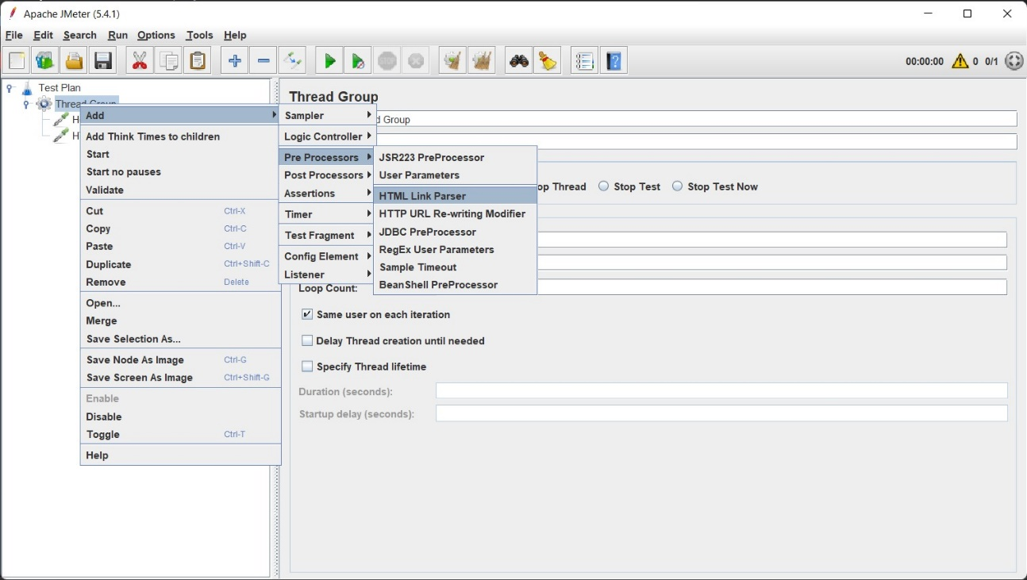

* ( .* executes response of home (request) retrieved by html parser)

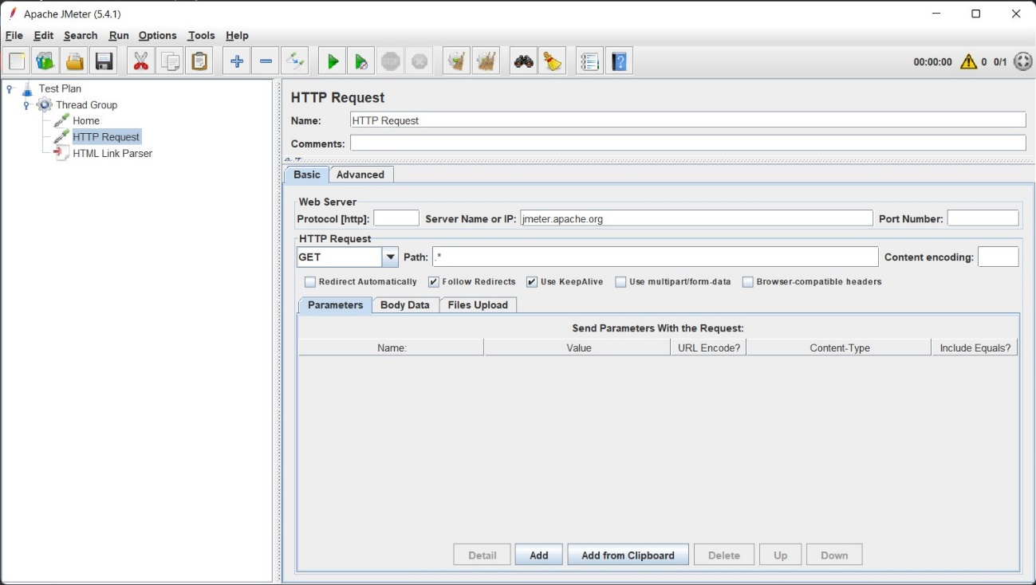

* Run

Http Resquest take a random link to test.

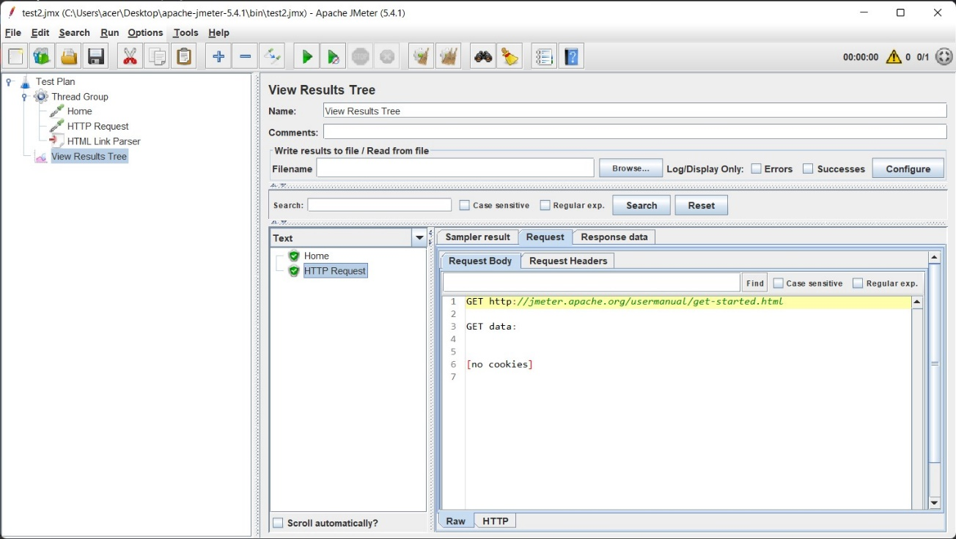

* Put HTTP request inside a while controller to test all url’s .

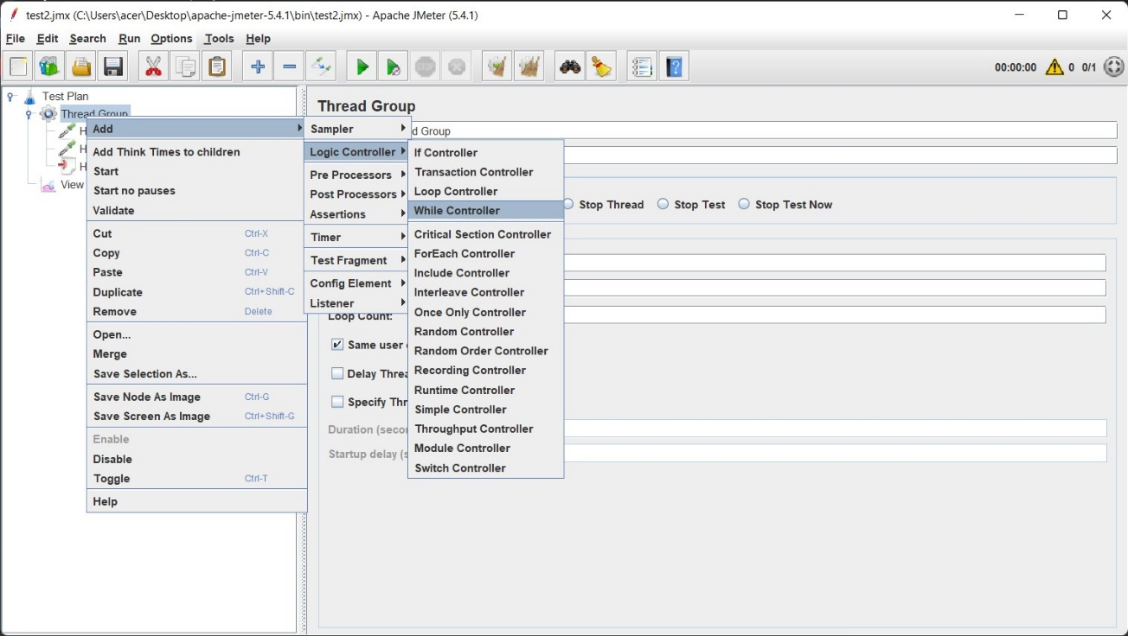

Run

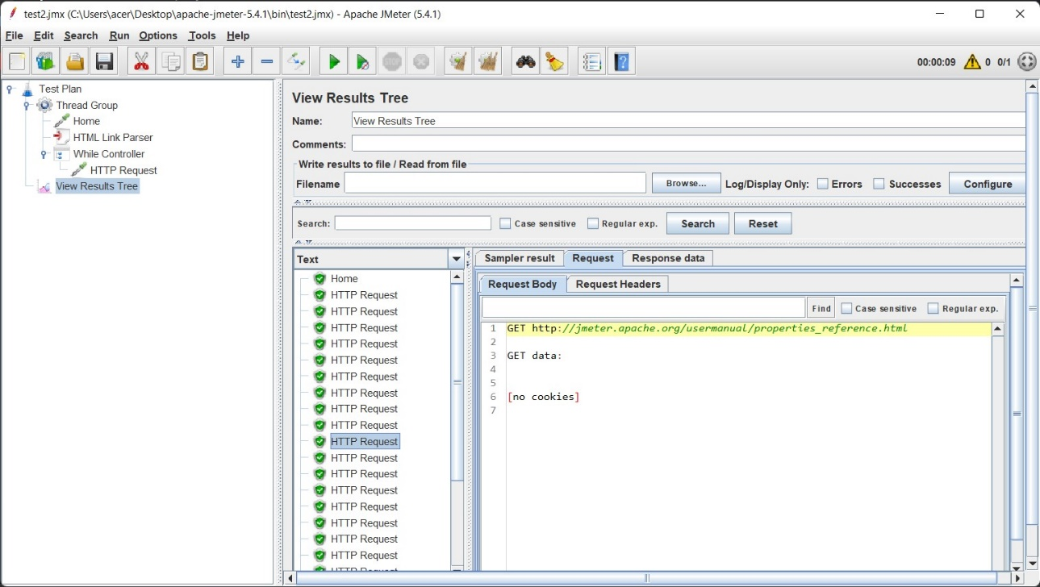

**Post-Processors**

Post-Processors are actions that are performed after your sampler has been executed. You can use them to perform some actions on your response or extract some values out from the response and save them in a variable that can be used later.

Result Status Action Handler: -

Result Status Action handler let the user select the action to be taken when sampler gets any error.

Steps:

* Create Thread Group
* Crete two Java Request
* 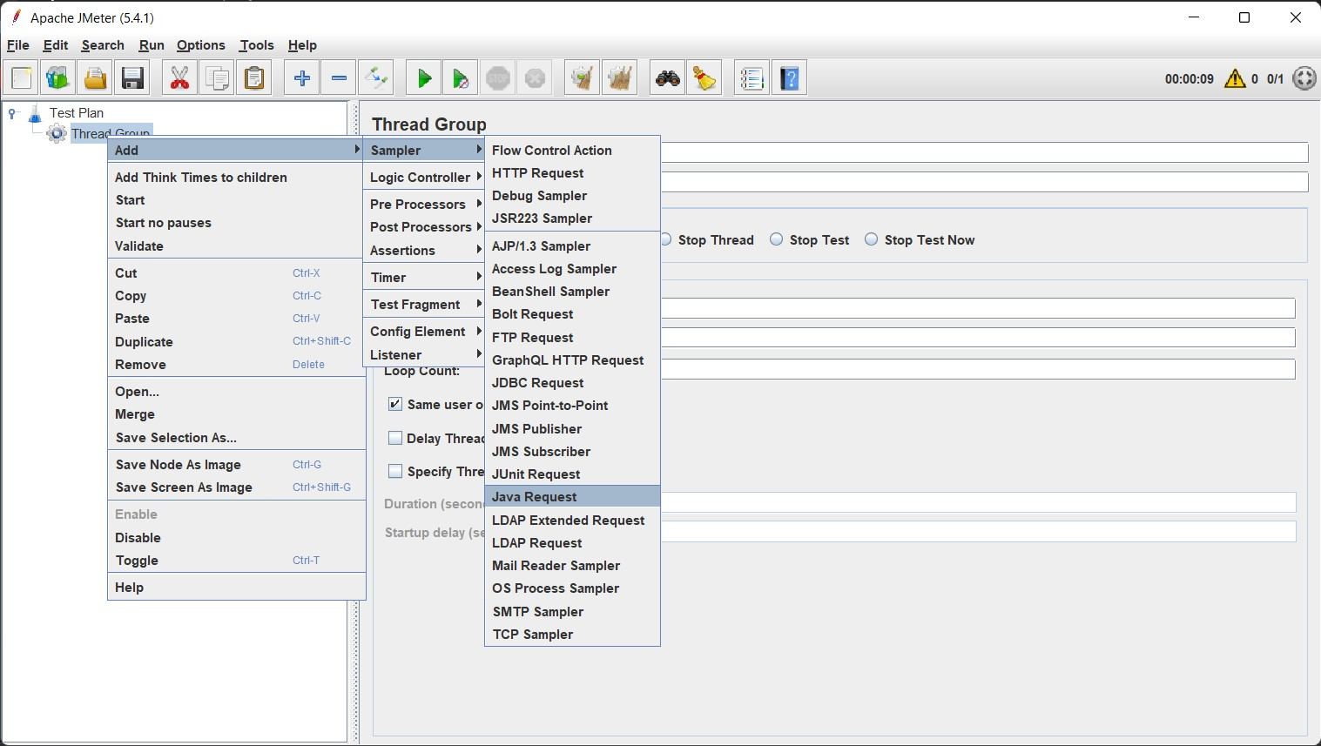
* Add 🡪 Post Processor 🡪 Result Status Action Handler

